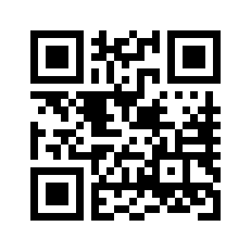
THE MUSICAL BOX SOCIETY OF GREAT BRITAIN
MEMBERSHIP HOW TO JOIN
Subscriptions run from 1st January each year and fall due on
1st January the following year.
Through our web site:
Go to: www.mbsgb.org.uk/membership and join instantly using your credit/debit card through PayPal. (You do not need a PayPal account to do this)
By Post:-
Fill in your details below and post to:
The Membership Secretary
MBSGB
The Grange Musical Collection
Palgrave
Diss
Norfolk
IP22 1AZ
Subscription Rates
UNDER 30: £15 Anywhere whilst under 30
NEW MEMBER £15 First Year Only
RENEWALS Single Joint (same address)
UK £27 £33
EU £32 £38
Rest of World £38 £46
Make cheques (£ Sterling only) payable to MBSGB

Please tell us how you found out about MBSGB and why you decided to join.
(Please tick all applicable boxes & add any comments)
☐Personal recommendation
☐Via internet search engine
☐Written publication
☐Meet other people with common interest
☐As a resource to increase existing knowledge/collection
☐Other

YOUR DETAILS
Please type or use Block Letters Second person at same address
Name (1)……………………………………...……. Name (2)……………………………………………
Surname…………………………………………… Surname……………………………………………
Address…………………………………………………………………………………………………….
………………………………………………………………………………………………………………
Country………………Post/Zip Code……………Year of Birth (if under 30)………………………….
Email ...............................................................Telephone.............................................................
DATA PROTECTION
When you are a member we store and process your name and address in order to send you our journal The Music Box. We would also like to use your e-mail address and telephone number to contact you with details of events or important MBSGB business matters, and to pass on to other members on request.
CONSENT
(To comply with the EU General Data Protection Regulation (GDPR))

In order for us to use your e-mail and telephone number to contact you and pass to other members
we need your consent. Please tick the appropriate boxes if you wish to consent

E-mail address
☐For MBSGB to contact me
☐For other members to contact me

Telephone No.
☐For MBSGB to contact me
☐For other members to contact me
Signature______________________________________Date_____________________
Society use only
Mem. No.
1st Mag

